**Project 1.2**

**By Shabnam**

1) Write a mapreduce/pig program to calculate the number of cases investigated under each FBI code

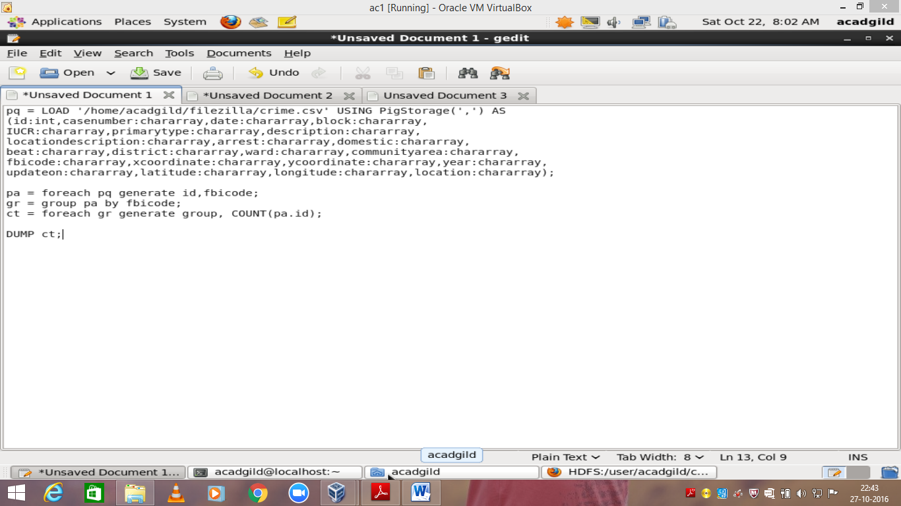

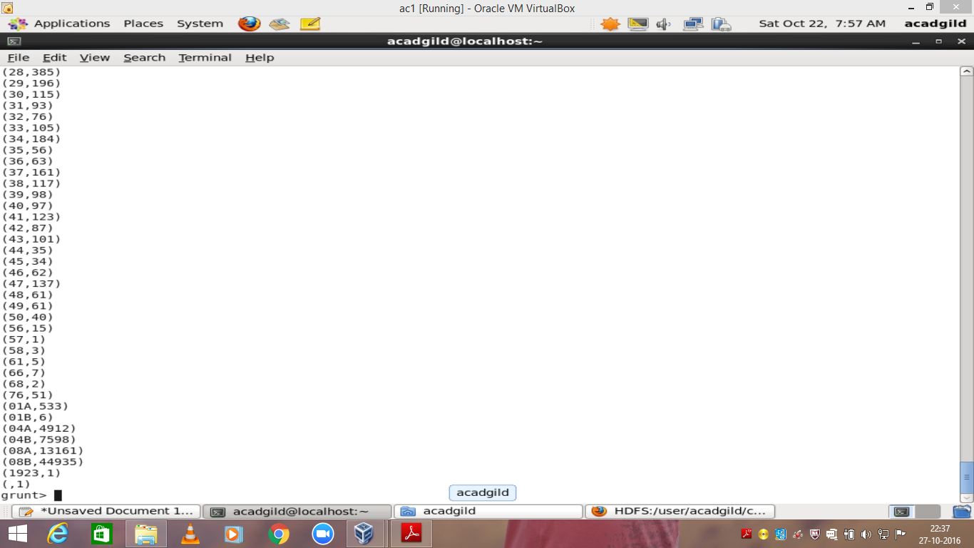

2) Write a mapreduce/pig program to calculate the number of cases investigated under FBI code 32.

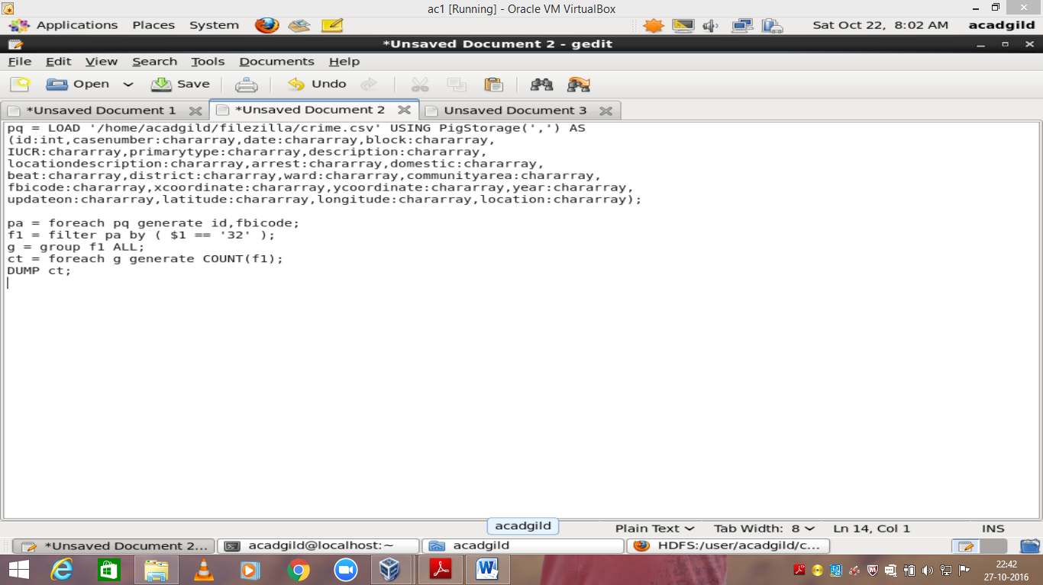

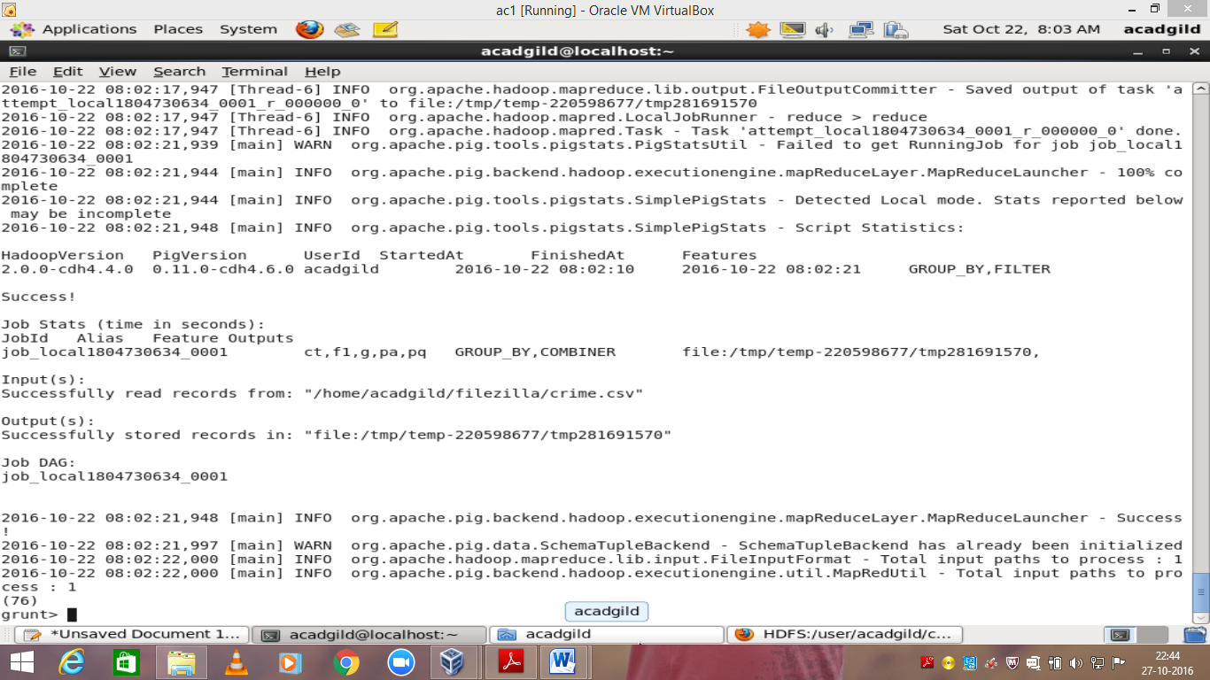

3) Write a mapreduce/pig program to calculate the number of arrests in theft district wise.

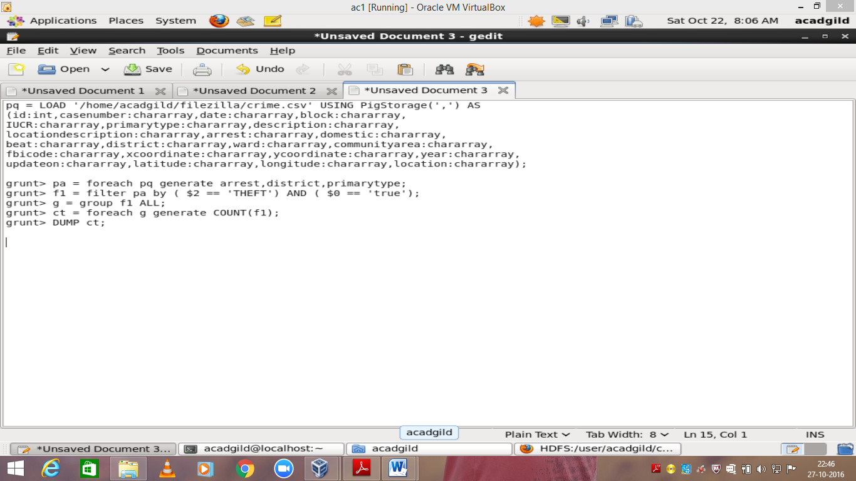

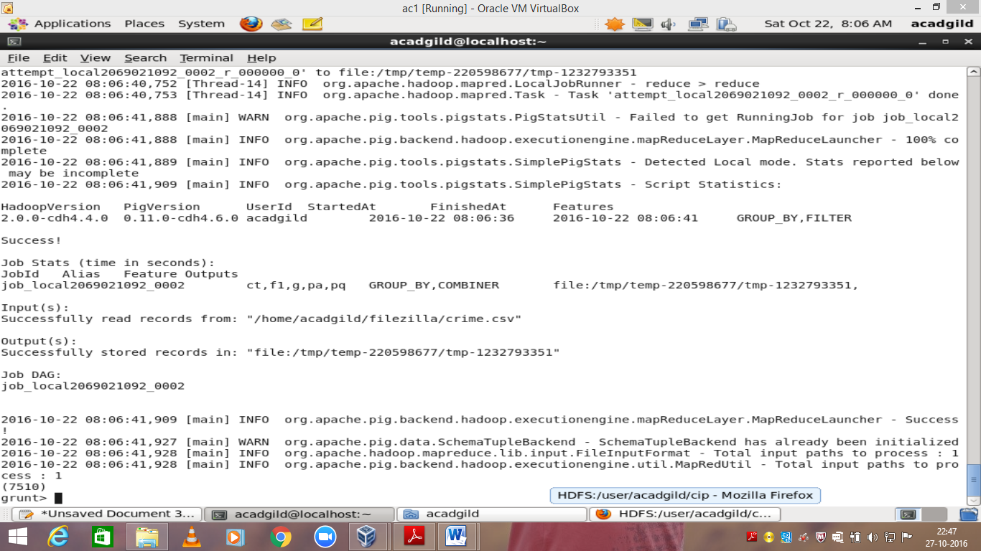

4) Write a mapreduce/pig program to calculate the number of arrests done between october 2014 and october 2015.

